Willow Hill Elementary Parent Teacher Organization (PTO) 2017-2018

Executive Board
2017-2018
President
Julia Coleman
Vice President
Nichole Parsons
Treasurer
Lyndra Barnes
Secretary
Jennifer Riviezzo
Assistant
Secretary
Amira Aliu

www.willowhillpto.weebly.com/index.html

WillowHillPTO@gmail.com

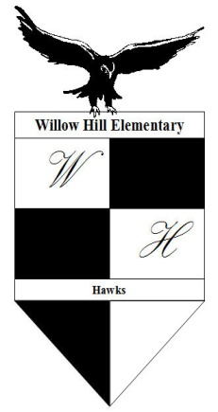
1700 Coolidge Avenue, Willow Grove, PA 19090  215.657.3800

To All Our Wonderful Room Parents,
We would like to thank you for volunteering this year! Your continued commitment has guaranteed the students of Willow Hill many wonderful memories and this is greatly appreciated.
To eliminate confusion or previous miscommunication regarding class activities/events, we are providing the following information:
Do
- All parent volunteers must complete the Abington School District (ASD) Clearance Process and receive an ASD badge permitting student engagement through the activities and events at the school.
- All class related activities/events are to be discussed with and agreed to by the Teacher, room parent representative(s) and any parent volunteer involved in the activity. The teacher will make the final decision regarding classroom activity and therefore, can change/revise/delete/cancel any class function at their discretion. Please be reminded the teacher is responsible for any happenings in the class.
- Ask and encourage parents to voluntarily bring food items in for the class activity. You have the option to assign from a list of healthy foods, but there must be a category for “other item” to allow parents to decide what they can bring without obligation.
- Encourage parents to attend the class festivities.
- If permitted by your child’s teacher, make fliers regarding the class activities and events. Sending home a note with a suggested item for a seasonal celebration is allowed. All fliers or notes must first be reviewed by your child’s teacher for approval before distribution.
- Remind parents of an alternative event being offered for students who have personal beliefs regarding celebrations.
- If monetary donations are being requested, $3.00/child is the acceptable amount. Individual parents may choose to give a gift to any Willow Hill staff.
To further assist you, we have provided guidelines for class parties and events. With your help and cooperation we can continue to offer the students of Willow Hill a year to remember! Should you have any questions please contact the Room Parent Representatives or any member of your PTO. We are happy to assist you!

Warmest Regards,
Jennifer Riviezzo, Grades K-3
Jennybaby1207@hotmail.com
Julia Coleman, Grades 4-6
Jcwhpto1700@gmail.com
Room Parent Representative Coordinators

The Abington Board of School Directors assumes no responsibilities for the opinions, information, and possible typographical errors or omissions, etc., that may be reflected in this flyer.

GUIDELINES FOR CLASS PARTIES/ACTIVITIES

Event: All Class Related Parties and Festivities

- Most teachers prefer to plan the class parties and festivities. Hence, contact them to find out if they want you to plan it or how you can assist with the party.

- Find out from the teacher if a balanced healthy menu has been prepared. Your child’s teacher has the best knowledge of which child has food allergies.

- Confirm with the teacher what activity is planned or will be planned. Usually it is a very short activity for the students to do in class due to time for example watching a movie, playing a math game, etc.

- If the teacher has not sent home fliers asking for food donations, offer to contact the parents of students in your class about the menu and activity.

- In addition:
  - Encourage all parent volunteers to get their clearances with the Abington School District. If they need help, please contact our Volunteer Clearance Office, Loretta Henry, at WillowHillPTO@gmail.com.
  - Invite and encourage all the parents to attend the event.
  - Encourage and ask who can come earlier to help with set up.
  - Paper products are usually the biggest need.
  - Items can be dropped off in the morning of the event or brought in 45 minutes before the event.
  - Your child’s teacher is in charge.

- Any questions, contact your Room Parent Representative Coordinators.

- Most of all have fun with your child and their class!
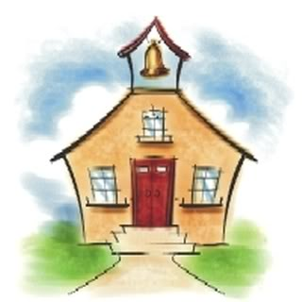
Room Parent Representatives is a subcommittee of the Willow Hill Parent Teacher Organization.
Email: WillowHillPTO@gmail.com
Website: www.willowhillpto.weebly.com/index.html
The Abington Board of School Directors assumes no responsibilities for the opinions, information, and possible typographical errors or omissions, etc., that may be reflected in this flyer.

