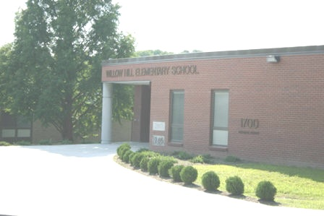
Parent Teacher Organization
2017-2018
Willow Hill Elementary
Welcome to Willow Hill whether you are a returning student and family or a brand new!
1700 Coolidge Avenue
Willow Grove, PA 19090
215.657.3800

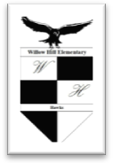
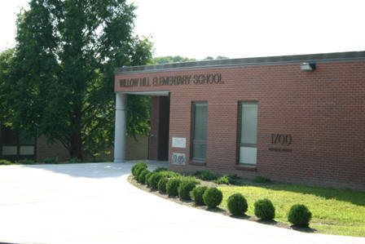
Willow Hill Elementary School Over 45 Years of
Success in Education
215-657-3800 Office
215-884-0568 Fax

WILLOW HILL PTO Executive Board 2017-2018 Theme: For Our Children
PTO MEETING DATES 2017-2018
School Library 6:15PM “Meet & Greet”
6:30PM Meeting Begins (unless specified)
September 19 | Subject to change depending on the weather.
October 5
November 9
January 17
February 9
March 5
April 18
May 23
June (TBA)
PTO Officers
President | Julia Coleman
Vice President | Nichole Parson
Treasurer | Lyndra Barnes
Secretary | Jennifer Riviezzo
Assistant Secretary | Amira Aliu
Teacher Representative | Multiple persons
Principal | Damon Jordan

EVENT | WHEN | DESCRIPTION | COORDINATORS
Spirit Day | Monthly: Every 4th Fri. of the Month unless specified | Rah, rah!!! Cheer on the Hawks!!  School community spirit strengthens our student’s resolve to work at their highest level, fosters appropriate behavior among themselves as well as bond parents, teachers and students together. | PTO Board  School
Scholarship Dance | TBA | Proceeds benefit the Abington High School graduates. The PTOs/PTAs contribute financially to this event. | TBA
Ice Cream, Ice Pops, Brownie or Cake Socials | TBA | Class room camaraderie is seen in our Box Top, sporting and academic competitions. These socials reward our students for their efforts. It’s the PTO’s way of saying, “JOB WELL DONE!! YOU DESERVE IT!! | Parent Volunteer
Holiday Shoppe | Monday, November 27- Thursday, November 30, 2017 | Holiday Items for sale | Lyndra Barnes
New Family Welcome | All school year | New families to the Willow Hill Community are given recognition as well as needed information to navigate their child’s school experience. | PTO Board  School
Kindergarten Breakfast | November | To invite the kindergarten families to Willow Hill Elementary, the school organizes a special breakfast which will allow parents to meet each other as well as teachers and staff. The PTO provides refreshments at this event | Parent Volunteer
Community Awareness Events | Friday, August 25, 2017  November 2017  Monday, November 27- December 1, 2017 | 3-Day Breast Cancer Walk “Cheer-a-thon”  Alzheimer’s Awareness Month  Toys for Tots Toy Drive  These projects give our students a more rounded academic experience and make them in tune with social issues and events. | PTO Board  School  The individual organizations
Hawk Eye | 2017:September , November, 2018: January, March, May | A bi-monthly publication which highlight the achievements of Willow Hill students, emphasize any key aspect the school is promoting and in general, build positivity within the community. | Communications Committee

Parent Council | See school district calendar for specific dates and locations of meetings | Parent Council is a district-wide parent organization. It consists of members form all Abington School District PTO/PTAs (all Elementary, Junior High and High Schools). It is open to all parents. There is usually a short program with a speaker followed by a business meeting and reports from the Superintendent’s Office. Members of the School Board also attend specific meetings. | Julia Coleman or Parent Volunteer
Connect | Coincides with monthly PTO meeting | After each PTO meeting, emails are sent to the attendees highlighting specific issues from the meeting, reminders of events, and thanking parents for their support. | Communications Committee
Back to School Picnic | Friday, September 8, 2017 | Family social activity. Get to know the other members of the school community including staff. | PTO Board  School
Fundraisers | All school year | Our primary fundraisers for the year are Race for Education, Gianni’s Pizza Kits and Mixed Bags. Other events include KidStuff Book Sales, Box Tops, Whingo Nights, 6th Grade events, Family Fun Nights such as Riviera, Movie Night, and the Annual May Family Fair, monetary donations and much more.  The funds raised pay for field trips, school sponsored events, specific enhancement programs (Art, Music, Gym, Science, etc.), and other school projects and programs. | PTO Board  School
Box Tops/ Campbell’s Labels For Education | All school year | This is a sure, fast way to raise revenue for the school. Parents purchase items with the Campbell’s box top. Based the Box tops collected, monies are earned. | Parent Volunteer  Vice President
WHingo Night | Tuesday, October 17, 2017 &  Thursday, March 22, 2018 | Family event intended to stimulate community interaction and connection. Students with their families and friends play Bingo with a Willow Hill twist. | PTO Board
May Family Fair | Friday, May 4, 2018 | Another family activity. It is the highlight of the school year with many games, prizes, food and activities. | PTO Board
Special Assembly | TBA | The PTO rewards the students for job well done by scheduling and coordinating special assemblies such as Pages for Progress. We are looking at providing more assemblies of this kind in the near future. | Dennis Coleman, Jr.
Room Parents (RPRs) | September to June | Parents are encouraged to participate in their child’s class room experience by coordinating parties and representing the parents of their child’s class. | Julia Coleman
Communication Packets | Weekly | They are the PTO and other organizations’ means of communicating with families about upcoming events, extra-curricular activities and matters of importance. | Communications Committee
School sponsored events | Please refer to the school district and Willow Hill calendars for specific dates. | Coffee with the Principal, Open House, Parent Child Book Club, Hawk Assembly, Honor’s Assembly, Reading Night, Math Night, SWPBS, RTI, Platinum Card Night, Basketball Classic, Stompers, School Board Meetings, Black History Assembly, Class parties, Art Show and Curriculum Night, Resource Night, Kindergarten Orientation, Volunteer Breakfast, Field Day, 6th Grade Ceremony, Reading Olympics, Giant A+ Program  This is by no means an exhausted list. Each event requires and requests your attendance and support. Our children will be stimulated, motivated and engaged as you participate in each event.  Please note Field Trips and volunteering in your child’s class, the computer lab or library requires a clearance badge issued by the Abington School District. For more information on Volunteer Clearances, please contact us at WillowHillPTO@gmail.com. | School
BAND | All year | This is a wonderful way to stay engaged and in touch with the student body. It is an app on your phone that allows access to the closed group (by invite only). To join, please provide your cell phone number or email address. | Communication Committee

